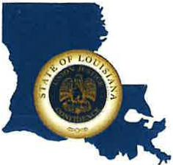 | CAPITAL AREA GROUNDWATER CONSERVATION DISTRICT
GARY I. BEARD
EXECUTIVE DIRECTOR

MEETING NOTICE
Capital Area Groundwater Conservation District
Executive Committee Meeting

WHEN: Tuesday, October 31, 2023

TIME: 9:30 a.m.

WHERE: Baton Rouge Marriott
5500 Hilton Ave.
Baton Rouge, LA 70808

Contact Person: Lisa Manda, (225)293-7370

